No1.

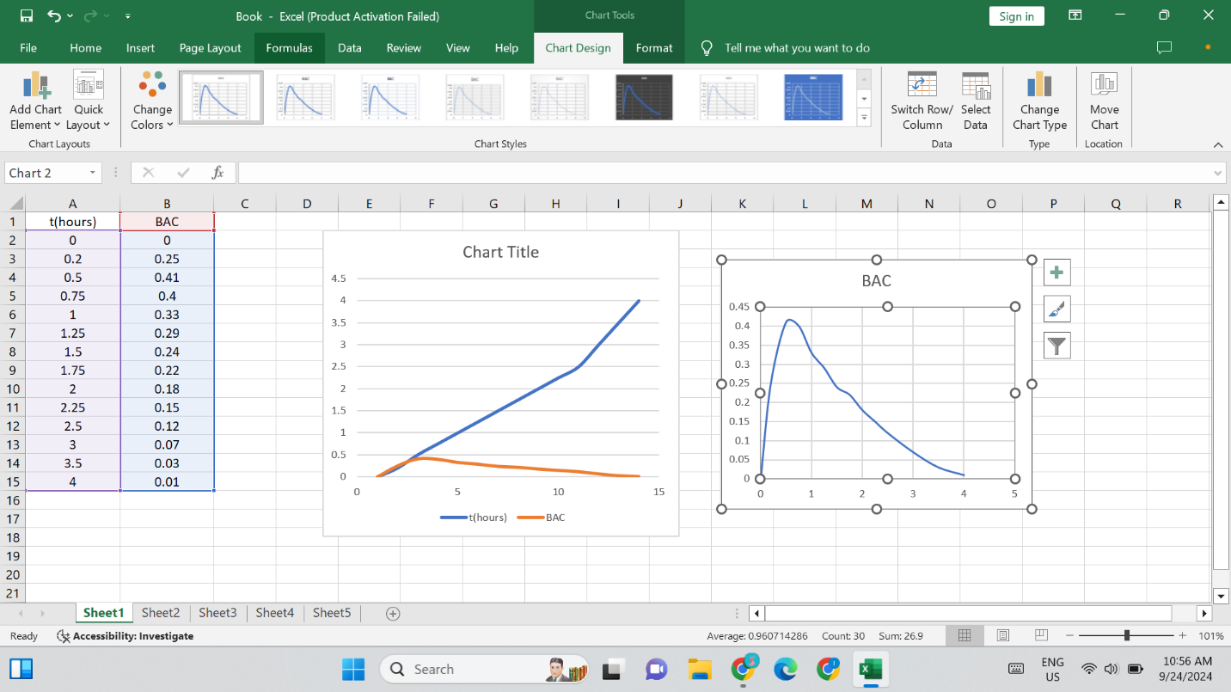

Initially, BAC increases with time. After 0.5 hours, BAC decreases steadily over time. By 4 hours, BAC approaches 0. The graph shows a rapid increase followed by a slower decline in BAC.

No.2

X2+(y-2)4=4

(y-2)4=4-x2

y-2=

y= +2

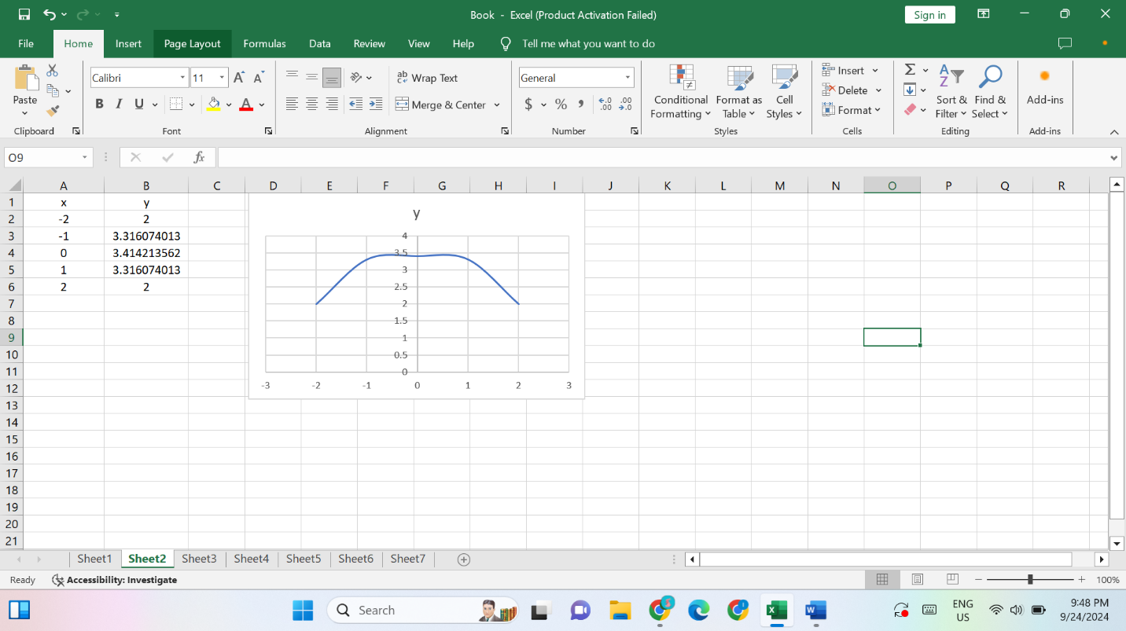

No.3

(a)

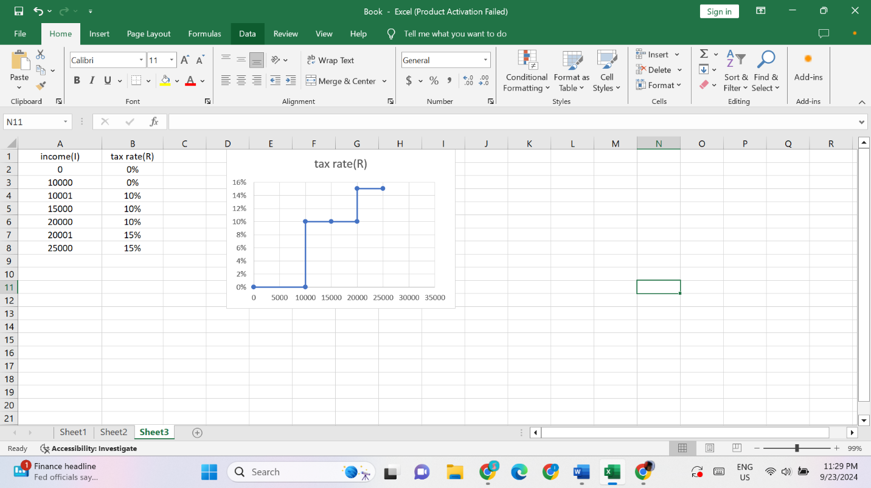

(b)

The income tax assessed on an income of $14,000 is

10% ($4000) = $400

The income tax assessed on an income of $26,000 is

10% ($10,000) + 15% ($6000) = $1000+$900=$1900

(c)

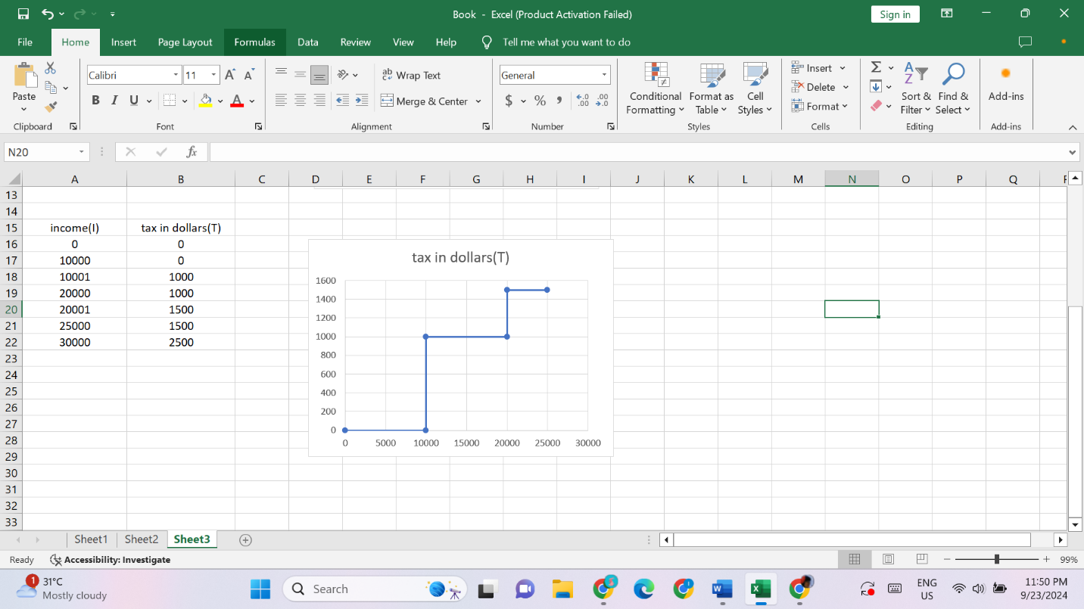

No4.

Graph a

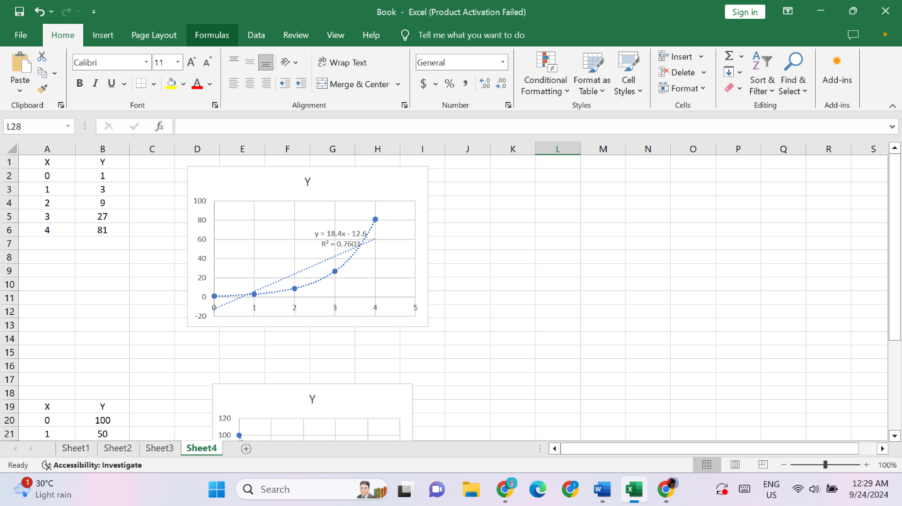

Graph b

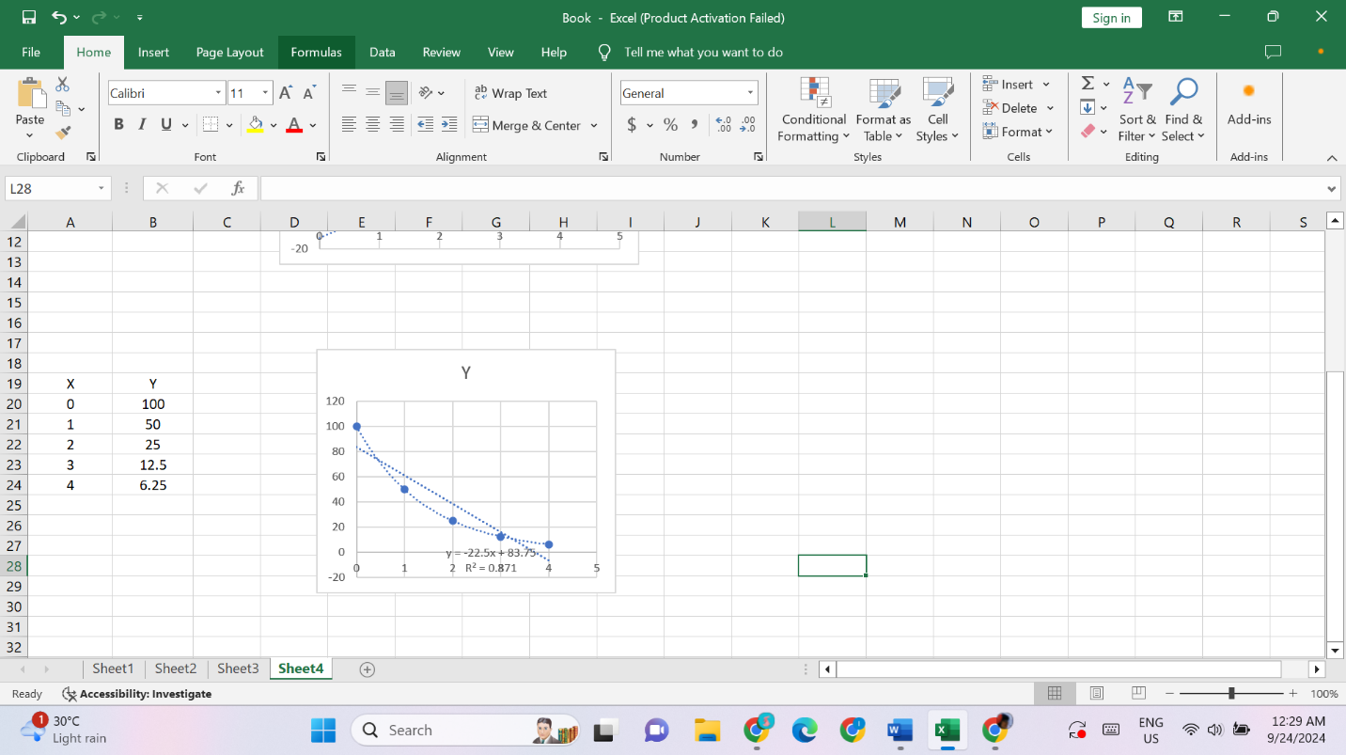

No.5

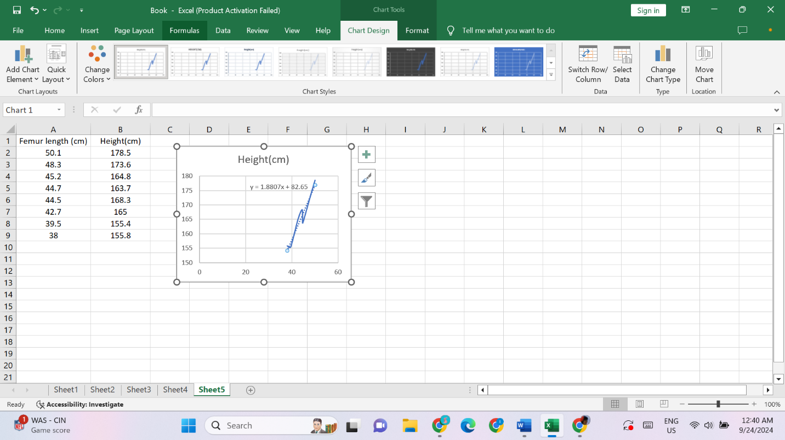

Use the equation y=1.8807x + 82.65 where x=53cm

y=1.8807\*53 + 82.65

y= 182.3 cm

So, the person height is 182.3 cm when his femur length is 53cm.

No6.

(a)

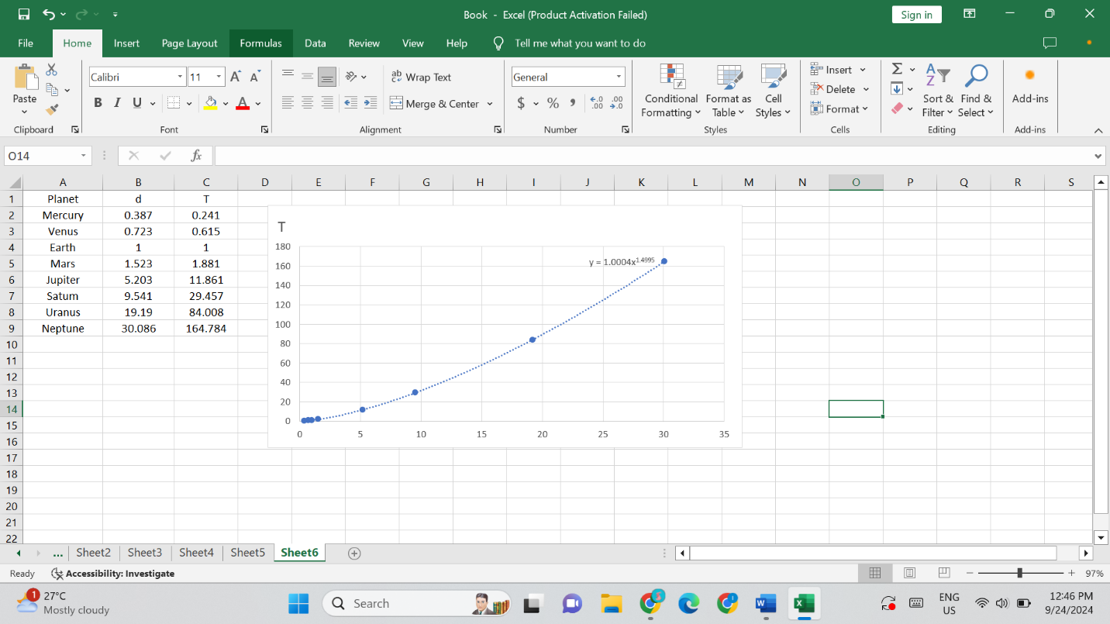

So, the equation is y=1.0004 x1.4995

(b)

By Kepler’s Third Law of Planetary,

T2 ∝ d3

T2=kd3

T=kd3/2

(c)

The equation in the model, y=1.0004 x1.4995

Thus, 1.4995 is nearly equal to 3/2(1.5).

So, my model corroborates Kepler’s Third Law.

No.7

1. y=sinx

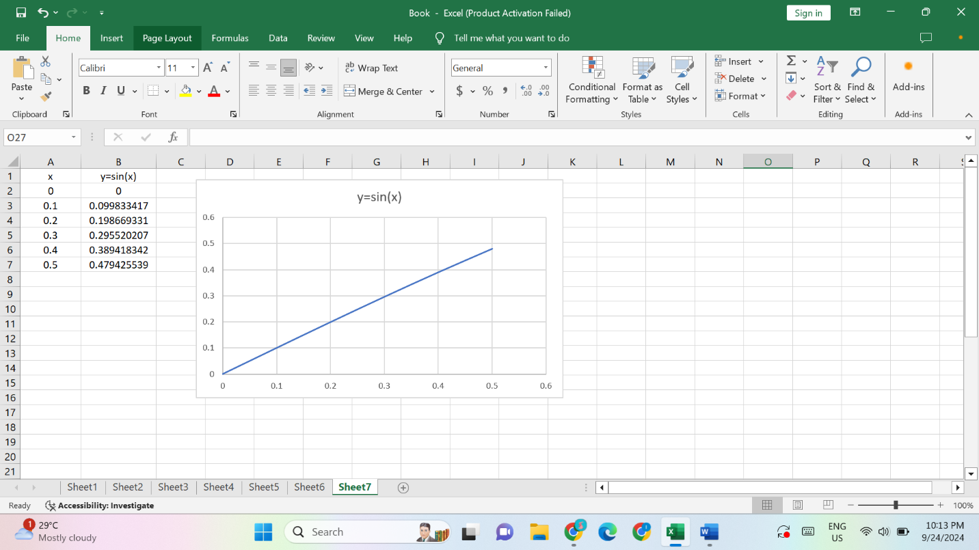

1. y=

y=

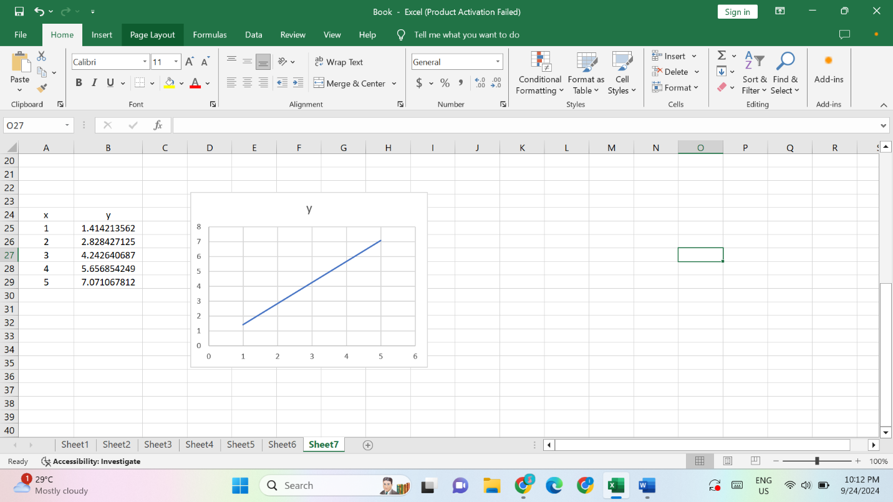

No.8

1. (g.f)(6)

= g(f(6))

when x=6 so, y=6

=g(6)

but graph g appears only to cover the value of x is from -4 to 4. So, it is undefined at x=6.

Consequently, (g.f)(6) is undefined because g(6) does not exist.

1. (g.g)(-2)

=g(g(-2))

=g(1)

=4

1. (f.f)(4)

=f(f(4))

=f(2)

=-2